IT101 – Software Applications
Access Chapter 2
In-Class Activity

- Download from week 7 of our class schedule the Volt Recruiters-ch2.accdb Database and save it to your I: drive or flash drive.
- Open Access and then Office Button/Open the Volt Recruiters-ch2.accdb database
- You will see there’s a Client Table and a Recruiters table in the database. (Similar to the ones we created last week.)
- Double-click the Client table and view the records (datasheet view). Also go into design view to see how the table was designed. When you are done, close the table.
- Now let’s create some queries.
Query #1. Suppose we’d like to create a list of all our clients and the city in which they are located. We’d like to know the clients’ client number, name, and city.
- To create this query, click on the Create tab then the Query Design icon.
- You will see both of the tables listed in the “Show Table” dialog box. Click the table you are interested in, and then click the “Add” button.

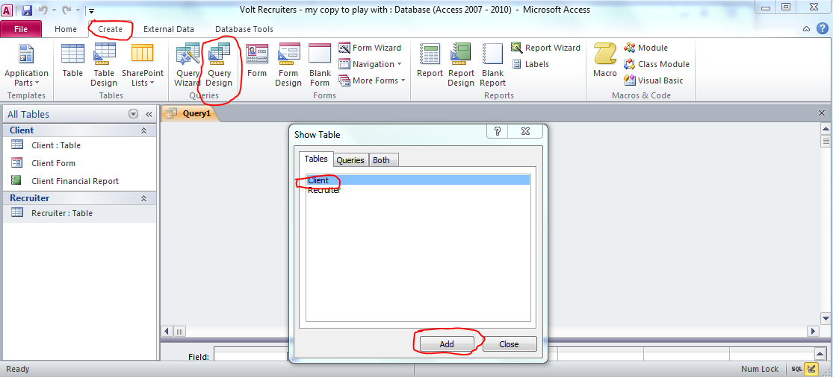

- You’ll see your query design window is now broken down into two parts. The top half shows the table we selected and the fields available within the table. The bottom half is the design grid where we can design the query.
Now click and drag down into the design grid the Client Number, Client Name and City fields since those are the fields we’d like to use in our query.
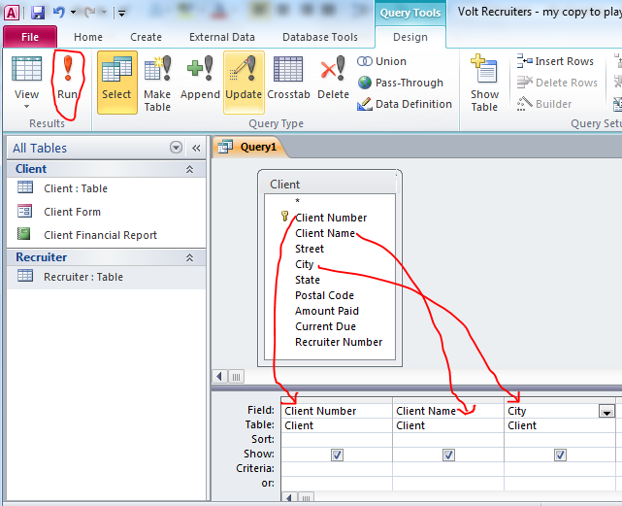
Finally, click the “Run” button (it’s the large red exclamation mark), to execute the query and see the results.
Let’s save this query as “Query 1 – Your last name” . It’s a good idea to name your queries as indicated in the schedule and hyphenate your last name on them. That way, when they come off the printer, your name will be on them.
Close the Query 1.

Query #2. Begin a new query (don’t try modifying your old one). This query should extract from the client table, the client number, client name, current due and recruiter number fields for all records with a recruiter number of 24. Let’s sort the results in descending order by current due.
Query #3. Create a new query. This query should extract from the client table the client number, client name and city fields for all the clients who live in Redmond.
Do you you think you got them all? What if the data entry person misspelled Redmond? Try using the “?” wildcard in your criteria as follows: Redm?nd and run the query
Now try: Redm*nd as the criteria.
“?” and * are the two wildcard characters that can be used in the criteria. What do you think the difference is between these two? (See pg AC83)
Query #4. Create a new query. This query should extract from the client table the client number, client name, amount paid, current due and recruiter number fields for those clients who have recruiter number 21 and who have a current due amount of $12,000 or more.
How many records met this criteria? _________________
Query #5. Use the same fields as in query 4 but create the criteria to extra records for those clients who have recruiter number 21 or who have a current due amount of $12,000 or more.
How many records met the criteria this time? _______________
Query #6. This query should extract from the client table, the client number, client name, amount paid and current due. Let’s also create a calculated field to determine the total amount of business we’ve performed for these clients. To do so, click in the first vacant column in the design grid on the “field” row and type the following:
Total Amt:[Amount paid]+[Current Due]
Now run the query.
Query #7. Start a new query and include both the Client and Recruiter tables. From the client table, place the following in the design grid: Client Number, Client Name, and Recruiter Number. From the Recruiter table, place the last name and first name fields in the design grid. Now run the query.

